

**A PROJECT REPORT ON**

**WEBSITE ‘POOJA ELECTRONICS’**

By

**PALAK GUPTA**

**Batch-EON (2021-5736)**

**Under the Guidance of,**

**AMRUTA DEORE**

**(Technical Trainer)**

**EduBridge India Pvt. Ltd.**

**INDEX**

* ABSTRACT ……………………………………………………………04
* CONTENTS …………………………………………………………..05

1. **INTRODUCTION**

1.1 . INTRODUCTION TO PROJECT……………………..05

1.2 . PURPOSE OF THE PROJECT…………………….....05

1.3 . EXISTING SYSTEM & ITS DISADVANTAGES…..06

1.4 . PROPOSED SYSTEM & ITS ADVANTAGES…….06

**2. REQUIREMENTS SPECIFICATION**

2.1 . FUNCTIONAL REQIREMENTS…………………………07

2.2 . SOFTWARE REQUIREMENTS…………………………09

2.3 . HARDWARE REQUIREMENTS………………………..09

2.3.1 . INTRODUCTION OF HTML…………………11

2.3.2 . INTRODUCTION OF CSS……………….13

2.3.2 . INTRODUCTION OF JAVASCRIPT…………14

2.3.2 . INTRODUCTION OF VISUAL BASIC………19

**3. SYSTEM DESIGN**

3.1 . FLOW CHART**……………………………………………….21**

3.2 . DATA FLOW DIAGRAM**…………………………………22**

3.3 . E R DIAGRAM**……………………………………………….23**

**4. CODING AND OUTPUT SCREEN ……………………24-28**

4.1 . HOME PAGE**………………………………………………….29**

4.2 . ABOUT US PAGE**…………………………………………30**

4.3 . SERVICES PAGES**………………………………….31**

4.4 . CONTACT US**………………………………………….32**

4.5 . GALLERY**……………………………………….33**

**4.5.1 . APPLIANCES……………………..34**

**4.5.2 . MOBILE ……………………………….35**

4.6 . OUR INFORMATION**………………………………….36**

**4.6.1 . FACEBOOK PAGE……………………………37**

**4.6.2 . WHATSAPP PAGE…………………………38**

**4.6.3 . INSTAGRAM PAGE……………………….39**

4.7 . FOOTER INFO**…………………………………………….40**

**5. CONCLUSION……………………………………………………………….41**

**6. REFERENCE**……………………………………………………………………42

**ABSTRACT**

Offering guests the best in quality and services has been the primary principle at pooja mobile and electronics. Since its inception by Mr. Ankit Gupta , a visionary with astute business accumen and forsight.

A marvellous journey that began with a small mobile shop at Raipur in 2008 , Pooja Mobile and Electronics has since evolved and has becoe one of the best electronic showroom in chhattisgarh. Ankit gupta promises of serving their customer with the absolute best in both in both product and after sales services.

**Existing System:**

My project is on online website.built for electronic shop so as to show cast its product And services along with other benefits to customer. It contains pictures and details of product available in the shop .Its also contains. Address of the shop and contact. Number of the shop owner For convenience of customers whoever intrested to buy electronic product.

**Proposed System:**

In future. There is also incorporation of. Each and every product. Along with its price. Discount available on each product how to claim discount. Features of the electronic product And its warranty.

**CHAPTER – 1**

**INTRODUCTION**

* 1. **.INTRODUCTION AND OBJECTIVE:**

My project is on online website.built for electronic shop so as to show cast its product And services along with other benefits to customer. It contains pictures and details of product available in the shop .Its also contains. Address of the shop and contact. Number of the shop owner For convenience of customers whoever intrested to buy electronic product. Offering guests the best in quality and services has been the primary principle at pooja mobile and electronics. Since its inception by Mr. Ankit Gupta , a visionary with astute business accumen and forsight.

**1.2. PURPOSE OF THE PROJECT**

Its purpose is to create a common Website of online electronic showroom. So users can visit here and can access website like services , contact , about owner and staff.

**1.3. EXISTING SYSTEM & DISADVANTAGES:**

It doesn't contain price of the product and. There is no detail of features of the product in existing system.

**1.4. PROPOSED SYSTEM & ITS ADVANTAGES:**

* This will allow customer to play order without even visiting the shop. Being able to buy any time , any place , anywhere.
* Site enables them to browse before they shop , and to research the product so they have more confidence in what they are buying.
* Online shopping become more enjoyable and easier than real-world shopping

**CHAPTER -2**

**REQUIREMENT SPECIFICATION**

**2.1 FUNCTIONAL REQUIREMENTS SPECIFICATION:**

* HOME PAGE.
* ABOUT US PAGE.
* SERVICES PAGES.
* CONTACT US PAGE.

**HOME PAGE:** This page contain the information about the showroom like services , contact , brands , categories, etc.

**ABOUT US PAGE:** This page contain about the showroom.

**SERVICES PAGE:** In this page contain which services provided by Pooja electronic like brands, categories, finance company.

**CONTACT US PAGE:** Contain the address and contact information about showroom.

**Software Requirements**

* Operating System   : Windows10.
* Programming Language : HTML , CSS ,JAVASCRIPT.
* IDE’s : VISUAL STUDIO CODE.

**Hardware Requirements**

* RAM : 4.00 GB
* Processor: Intel CORE i3
* Hard disk: Minimum 10 GB

**INTRODUCTION TO HTML:**

HTML is an acronym which stands for **Hyper Text Markup Language** which is used for creating web pages and web applications. Let's see what is meant by Hypertext Markup Language, and Web page.

**Hyper Text:** HyperText simply means "Text within Text." A text has a link within it, is a hypertext. Whenever you click on a link which brings you to a new webpage, you have clicked on a hypertext. HyperText is a way to link two or more web pages (HTML documents) with each other.

**Markup language:** A markup language is a computer language that is used to apply layout and formatting conventions to a text document. Markup language makes text more interactive and dynamic. It can turn text into images, tables, links, etc.

**Web Page:** A web page is a document which is commonly written in HTML and translated by a web browser. A web page can be identified by entering an URL. A Web page can be of the static or dynamic type. **With the help of HTML only, we can create static web pages**.

Hence, HTML is a markup language which is used for creating attractive web pages with the help of styling, and which looks in a nice format on a web browser. An HTML document is made of many HTML tags and each HTML tag contains different content.

Description of HTML Example

**<!DOCTYPE>:** It defines the document type or it instruct the browser about the version of HTML.

**<html >** :This tag informs the browser that it is an HTML document. Text between html tag describes the web document. It is a container for all other elements of HTML except <!DOCTYPE>

**<head>:** It should be the first element inside the <html> element, which contains the metadata(information about the document). It must be closed before the body tag opens.

**<title>:** As its name suggested, it is used to add title of that HTML page which appears at the top of the browser window. It must be placed inside the head tag and should close immediately. (Optional)

**<body>**: Text between body tag describes the body content of the page that is visible to the end user. This tag contains the main content of the HTML document.

**<h1>** : Text between <h1> tag describes the first level heading of the webpage.

**<p>**: Text between <p> tag describes the paragraph of the webpage.

Brief History of HTML

In the late 1980's , a physicist, Tim Berners-Lee who was a contractor at CERN, proposed a system for CERN researchers. In 1989, he wrote a memo proposing an internet based hypertext system.

**Tim Berners-Lee** is known as the father of HTML. The first available description of HTML was a document called "HTML Tags" proposed by Tim in late 1991. The latest version of HTML is HTML5, which we will learn later in this tutorial.

HTML Versions

Since the time HTML was invented there are lots of HTML versions in market, the brief introduction about the HTML version is given below:

**HTML 1.0:** The first version of HTML was 1.0, which was the barebones version of HTML language, and it was released in1991.

**HTML 2.0:** This was the next version which was released in 1995, and it was standard language version for website design. HTML 2.0 was able to support extra features such as form-based file upload, form elements such as text box, option button, etc.

**HTML 3.2:** HTML 3.2 version was published by W3C in early 1997. This version was capable of creating tables and providing support for extra options for form elements. It can also support a web page with complex mathematical equations. It became an official standard for any browser till January 1997. Today it is practically supported by most of the browsers.

**HTML 4.01:** HTML 4.01 version was released on December 1999, and it is a very stable version of HTML language. This version is the current official standard, and it provides added support for stylesheets (CSS) and scripting ability for various multimedia elements.

**HTML5 :** HTML5 is the newest version of HyperText Markup language. The first draft of this version was announced in January 2008. There are two major organizations one is W3C (World Wide Web Consortium), and another one is WHATWG( Web Hypertext Application Technology Working Group) which are involved in the development of HTML 5 version, and still, it is under development.

Features of HTML

1) It is a very **easy and simple language**. It can be easily understood and modified.

2) It is very easy to make an **effective presentation** with HTML because it has a lot of formatting tags.

3) It is a **markup language**, so it provides a flexible way to design web pages along with the text.

4) It facilitates programmers to add a **link** on the web pages (by html anchor tag), so it enhances the interest of browsing of the user.

5) It is **platform-independent** because it can be displayed on any platform like Windows, Linux, and Macintosh, etc.

6) It facilitates the programmer to add **Graphics, Videos, and Sound** to the web pages which makes it more attractive and interactive.

7) HTML is a case-insensitive language, which means we can use tags either in lower-case or upper-case.

# INTRODUCTION OF CSS:

CSS stands for Cascading Style Sheets. It is a style sheet language which is used to describe the look and formatting of a document written in markup language. It provides an additional feature to HTML. It is generally used with HTML to change the style of web pages and user interfaces. It can also be used with any kind of XML documents including plain XML, SVG and XUL.

CSS is used along with HTML and JavaScript in most websites to create user interfaces for web applications and user interfaces for many mobile applications.

## What does CSS do

* You can add new looks to your old HTML documents.
* You can completely change the look of your website with only a few changes in CSS code.

## Why use CSS

These are the three major benefits of CSS:

## 1) Solves a big problem

Before CSS, tags like font, color, background style, element alignments, border and size had to be repeated on every web page. This was a very long process. For example: If you are developing a large website where fonts and color information are added on every single page, it will be become a long and expensive process. CSS was created to solve this problem. It was a W3C recommendation.

## 2) Saves a lot of time

CSS style definitions are saved in external CSS files so it is possible to change the entire website by changing just one file.

## 3) Provide more attributes

CSS provides more detailed attributes than plain HTML to define the look and feel of the website

**INTRODUCTION TO JAVASCRIPT:**

JavaScript (js) is a light-weight object-oriented programming language which is used by several websites for scripting the webpages. It is an interpreted, full-fledged programming language that enables dynamic interactivity on websites when applied to an HTML document. It was introduced in the year 1995 for adding programs to the webpages in the Netscape Navigator browser. Since then, it has been adopted by all other graphical web browsers. With JavaScript, users can build modern web applications to interact directly without reloading the page every time. The traditional website uses js to provide several forms of interactivity and simplicity.

Although, JavaScript has no connectivity with Java programming language. The name was suggested and provided in the times when Java was gaining popularity in the market. In addition to web browsers, databases such as CouchDB and MongoDB uses JavaScript as their scripting and query language.

Features of JavaScript

There are following features of JavaScript:

1. All popular web browsers support JavaScript as they provide built-in execution environments.
2. JavaScript follows the syntax and structure of the C programming language. Thus, it is a structured programming language.
3. JavaScript is a weakly typed language, where certain types are implicitly cast (depending on the operation).
4. JavaScript is an object-oriented programming language that uses prototypes rather than using classes for inheritance.
5. It is a light-weighted and interpreted language.
6. It is a case-sensitive language.
7. JavaScript is supportable in several operating systems including, Windows, macOS, etc.
8. It provides good control to the users over the web browsers.

History of JavaScript

In 1993, **Mosaic**, the first popular web browser, came into existence. In the **year 1994**, **Netscape** was founded by **Marc Andreessen**. He realized that the web needed to become more dynamic. Thus, a 'glue language' was believed to be provided to HTML to make web designing easy for designers and part-time programmers. Consequently, in 1995, the company recruited **Brendan Eich** intending to implement and embed Scheme programming language to the browser. But, before Brendan could start, the company merged with **Sun Microsystems** for adding Java into its Navigator so that it could compete with Microsoft over the web technologies and platforms. Now, two languages were there: Java and the scripting language. Further, Netscape decided to give a similar name to the scripting language as Java's. It led to 'Javascript'. Finally, in May 1995, Marc Andreessen coined the first code of Javascript named '**Mocha**'. Later, the marketing team replaced the name with '**LiveScript**'. But, due to trademark reasons and certain other reasons, in December 1995, the language was finally renamed to 'JavaScript'. From then, JavaScript came into existence.

Application of JavaScript

JavaScript is used to create interactive websites. It is mainly used for:

* Client-side validation,
* Dynamic drop-down menus,
* Displaying date and time,
* Displaying pop-up windows and dialog boxes (like an alert dialog box, confirm dialog box and prompt dialog box),

**INTRODUCTION TO VISUAL STUDIO CODE**

Visual Studio Code is a code editor in layman’s terms. Visual Studio Code is “a free-editor that helps the programmer write code, helps in debugging and corrects the code using the intelli-sense method ”. In normal terms, it facilitates users to write the code in an easy manner. Many people say that it is half of an IDE and an editor, but the decision is up to to the coders. Any program/software that we see or use works on the code that runs in the background. Traditionally coding was used to do in the traditional editors or even in the basic editors like notepad! These editors used to provide basic support to the coders.

Some of them were so basic that it was very difficult in writing basic English level programs in them. As time went by, some programming languages needed a specific framework and support for further coding and development it, which was not possible using these editors. VI Editor, Sublime Text Editor, is one of the many kinds of editors that came into existence. The most prominent and which supports almost every coding language is VISUAL STUDIO CODE. Its features let the user modify the editor as per the usage, which means the user is able to download the libraries from the internet and integrate it with the code as per his requirements.

### What can Visual Studio Code do?

Visual Studio Code has some very unique features. They are listed as below **Support for multiple programming languages:**Supports multiple programming languages. So earlier, programmers needed Web-Support: a different editor for different languages, but it has built-in multi-language support. This also means it easily detects if there’s any fault or cross-language reference, it’ll be able to detect it easily.

* **Intelli-Sense:**It can detect if any snippet of code is left incomplete. Also, common variable syntaxes and variable declarations are made automatically. Ex: If a certain variable is being used in the program and the user has forgotten to declare, intelli-sense will declare it for the user.
* **Cross-Platform Support:**Traditionally, editors used to support either [Windows or Linux or Mac Systems](https://www.educba.com/linux-vs-mac-vs-windows/). But Visual Studio Code is cross-platform. So it can work on all three platforms. Also, the code works on all three platforms; else, the open-source and proprietary software codes used to be different.
* **Extensions and Support:**Usually supports all the programming languages but, if the user/programmer wants to use the programming language which is not supported then, he can download the extension and use it. And performance-wise, the extension doesn’t slow down the editor as it rums as a different process.
* **Repository:**With the ever-increasing demand for the code, secure and timely storage is equally important. It is [connected with Git](https://www.educba.com/git-alternatives/) or can be connected with any other repository for pulling or saving the instances.
* **Web-Support:**Comes with built-in support for Web applications. So web applications can be built and supported in VSC.
* **Hierarchy Structure:**The code files are located in files and folders. The required code files also have some files, which may be required for other complex projects. These files can be deleted as per convenience.
* **Improving Code:**Some code snippets can be declared a bit differently, which might help the user in the code. This function prompts the user, wherever necessary, to change it to the suggested option.
* **Terminal Support:**Many of the times, the user needs to start from the root of the directory to start with a particular action, in-built terminal or console provides user support to not to switch in-between two screens for the same.
* **Multi-Projects:**Multiple projects containing multiple files/folders can be opened simultaneously. These projects/folders might or might not be related to each other.
* **Git Support:**Resources can be pulled from Git Hub Repo online and vice-versa; saving can be done too. Resource pulling also means cloning the code which is made available on the internet. This code can later be changed and saved.
* **Commenting:**A common feature, but some of the languages do not support it. Commenting on the code helps the user to recall or track according to the sequence he wants.

### Advantages and Why should we use Visual Studio Code

There are many advantages over any other IDE; they are as follow:

1. Cross-platform support :

* Windows
* Linux
* Mac

2. Light-weight

3. Robust Architecture

4. Intelli-Sense

5. Freeware: Free of Cost- probably the best feature of all for all the programmers out there, even more for the organizations.

6. Many users will use it or might have used it for desktop applications only, but it also provides great tool support for Web Technologies like; HTML, CSS, JSON.

**CHAPTER – 3**

**SYSTEM DESIGN**

**3.1 INTRODUCTION**

**Systems design**

It is the process or art of defining the architecture ,components , modules, interfaces, and data for a system to satisfy specified requirements. One could see it as the application of systems theory to product development. There is some overlap and synergy with the disciplines of systems analysis, systems architecture and systems engineering

**FLOW CHART:**

A flowchart is a diagram that depicts a process, system or computer algorithm. They are widely used in multiple fields to document, study, plan, improve and communicate often complex processes in clear, easy-to-understand diagrams. Flowcharts, sometimes spelled as flow charts, use rectangles, ovals, diamonds and potentially numerous other shapes to define the type of step, along with connecting arrows to define flow and sequence. They can range from simple, hand-drawn charts to comprehensive computer-drawn diagrams depicting multiple steps and routes. If we consider all the various forms of flowcharts, they are one of the most common diagrams on the planet, used by both technical and non-technical people in numerous fields.

CONTACT INFO

ADDRESS

FINANCE COMPANY

BRAND

CATEGORIES

SERVICE

CUSTOMER REVIEW

APPLIANCES

MOBILE

GALLERY

OUR INFORMATION

HOME

CONTACT US

SERVICES

HOME

ABOUT US

**DATA FLOW DIAGRAMS:**

Data flow diagram will act as a graphical representation of the system in terms ofinteraction between the system, external entities, and process and how data stored in certainlocation.

•External entities

•Data stores

• Process

• Data Flow

**0 level DFD:**

USER

ADMIN

**RESPONSE VISITS**

**1st level DFD:**

GALLERY

CATEGORIES

ALL BRANDS

OUR INFORMATION

CONTACT US

SEVICES

ABOUT US

HOME

**ER Diagram:**

* The ER model is a high-level data model diagram
* ER diagrams are a visual tool which is helpful to represent the ER model
* Entity relationship diagram displays the relationships of entity set stored in a database
* ER diagrams help you to define terms related to entity relationship modeling
* ER model is based on three basic concepts: Entities, Attributes & Relationships.

WEBSITE

USER OR CUSTOMER

VISITS

**CHAPTER-4**

**CODING & OUTPUT SCREEN**

**CODING:**

<!DOCTYPE html>

<html lang="en">

<head>

    <meta charset="UTF-8">

    <meta http-equiv="X-UA-Compatible" content="IE=edge">

    <meta name="viewport" content="width=device-width, initial-scale=1.0">

    <title>POOJA ELECTRONICS</title>

    <link href="https://unpkg.com/aos@2.3.1/dist/aos.css" rel="stylesheet">

    <link rel="stylesheet" type="text/css" href="css/style.css">

    <link rel="stylesheet" type="text/css" href="https://cdn.jsdelivr.net/npm/@fortawesome/fontawesome-free@5.15.4/css/fontawesome.min.css">

</head>

<body>

  <header>

      <nav>

          <div class="row clearfix">

            <img src="photos/logo.jpeg " class="logo">

              <ul class="main-nav">

                  <li data-aos="fade-up-left"><a href="#">HOME</a></li>

                  <li data-aos="fade-up-left"><a href="html/aboutus.html">ABOUT US</a></li>

                  <li data-aos="fade-up-left"><a href="html/services.html">SERVICES</a></li>

                  <li data-aos="fade-up-left"><a href="html/contactus.html">CONTACT US</a></li>

              </ul>

          </div>

      </nav>

      <div class ="main-content-header">

      <h1 data-aos="fade-up-right"> WELCOME TO <span class="colorchange">POOJA ELECTRONICS</span><br></h1>

          <h2> A COMPLETE MOBILE & ELECTRONIC SHOWROOM .</h2>

      </div>

  </header>

  <section class="data-filter">

      <div class="portfolio-menu">

          <ul>

              <li class="Active" data-filter="*">ALL</li>

              <li data-filter=".Appliances"> APPLIANCES</li>

              <li data-filter=".Mobile"> MOBILE</li>

              <li data-filter=".CustomerReview"> CUSTOMER REVIEW</li>

          </ul>

      </div>

      <div class="portfolio-item">

          <div class="item Mobile" data-aos="zoom-in-up" data-aos-offset="100" data-aos-delay="100">

          <img src="photos/12.jpeg" width="100" height="100">

          </div>

          <div class="item Mobile" data-aos="zoom-in-up" data-aos-offset="100" data-aos-delay="100">

            <img src="photos/13.jpeg" width="100" height="100">

            </div>

            <div class="item Mobile"data-aos="zoom-in-up" data-aos-offset="100" data-aos-delay="100">

                <img src="photos/9.jpeg" width="100" height="100">

                </div>

            <div class="item Mobile"data-aos="zoom-in-up" data-aos-offset="100" data-aos-delay="100">

                <img src="photos/14.jpeg" width="100" height="100">

                </div>

                <div class="item Appliances"data-aos="flip-left" >

                    <img src="photos/6.jpeg" width="100" height="100">

                    </div>

                <div class="item Appliances" data-aos="flip-left" >

                        <img src="photos/7.jpeg" width="100" height="100">

                        </div>

                <div class="item Appliances" data-aos="flip-left">

                            <img src="photos/8.jpeg" width="100" height="100">

                            </div>

                <div class="item Appliances" data-aos="flip-left" >

                                <img src="photos/10.jpeg" width="100" height="100">

                                </div>

                <div class="item Appliances" data-aos="flip-left" >

                                    <img src="photos/11.jpeg" width="100" height="100">

                                    </div>

                <div class="item CustomerReview" data-aos="zoon-in">

                                        <img src="photos/1.jpeg" width="100" height="100">

                                        </div>

                <div class="item CustomerReview" data-aos="zoon-in" >

                                            <img src="photos/2.jpeg" width="100" height="100">

                                            </div>

                <div class="item CustomerReview" data-aos="zoon-in">

                                                <img src="photos/3.jpeg" width="100" height="100">

                                                </div>

                <div class="item CustomerReview" data-aos="zoon-in" >

                                                    <img src="photos/4.jpeg" width="100" height="100">

                                                    </div>

                <div class="item CustomerReview" data-aos="zoon-in">

                                                        <img src="photos/5.jpeg" width="100" height="100">

                                                        </div>

      </div>

</section>

<section class="member">

<div class="member-info">

    <h1>OUR <span> INFORMATIONS</span></h1>

    <p>WHAT OUR OWNER SAYS</p>

</div>

<div class="member-card">

    <img src="photos/owner.jpeg" width="100">

    <p> Pooja electronics is a one of best showroom, Provides best services to customer. We always think and proceed according to our customer need and satisfactions. about our staff all are very polite. WELCOME TO POOJA ELECTRONICS.</p>

    <h2> * MR. ANKIT GUPTA </h2>

    <a href="https://www.facebook.com/people/Ankit-Gupta/100005355487973/"><img src="photos/facebook.jpeg" width="100"></a>

   <a href="https://wa.me/message/SHQXE7NBJYLCP1"><img src="photos/whatsapp.jpeg" width="100"></a>

   <a href="https://www.instagram.com/p/CTnEay4jsrA/?utm_medium=copy_link"><img src="photos/instagram.jpeg" width="100"></a>

    <a href=""><img src="photos/twitter.jpeg" width="100"></a>

</div>

</section>

<footer>

    <div class="Address">

            <h2>WELCOME TO POOJA ELECTRONICS.</h2>

            <p>WE'R A TEAM OF NON-CYNICS WHO TRULY CARE FOR OUR WORK.</p>

            <h3> Siddharth chowk ,Old dhamtari road</h3>

            <h3>Raipur-492001 , Chhattisgarh</h3>

            <h3> 9009188999 , 8871533100</h3>

            <h3>ankit.gupta9.ag@gmail.com</h3>

    </div>

</footer>

<script src="https://code.jquery.com/jquery-3.6.0.min.js" integrity="sha256-/xUj+3OJU5yExlq6GSYGSHk7tPXikynS7ogEvDej/m4=" crossorigin="anonymous"></script>

<script src="https://unpkg.com/isotope-layout@3/dist/isotope.pkgd.min.js"></script>

<script type="text/javascript">

$('.portfolio-item').isotope({

  // options

  itemSelector: '.item',

  layoutMode: 'fitRows'

});

     $('.portfolio-menu ul li').click(function()

     {

        $('.portfolio-menu ul li').removeClass('Active');

        $(this).addClass('Active');

        var selector =$(this).attr('data-filter');

        $('.portfolio-item').isotope({

            filter:selector

        });

        return false;

     });

</script>

<script src="https://unpkg.com/aos@2.3.1/dist/aos.js"></script>

<script>

    AOS.init();

  </script>

</body>

</html>

**OUTPUT SCREEN:**

**HOME PAGE:**

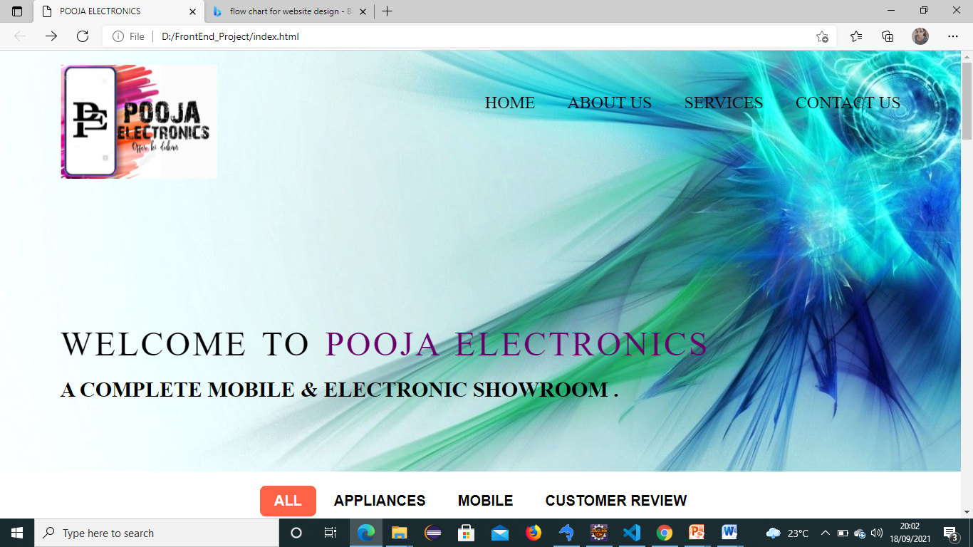

**ABOUT US PAGE:**

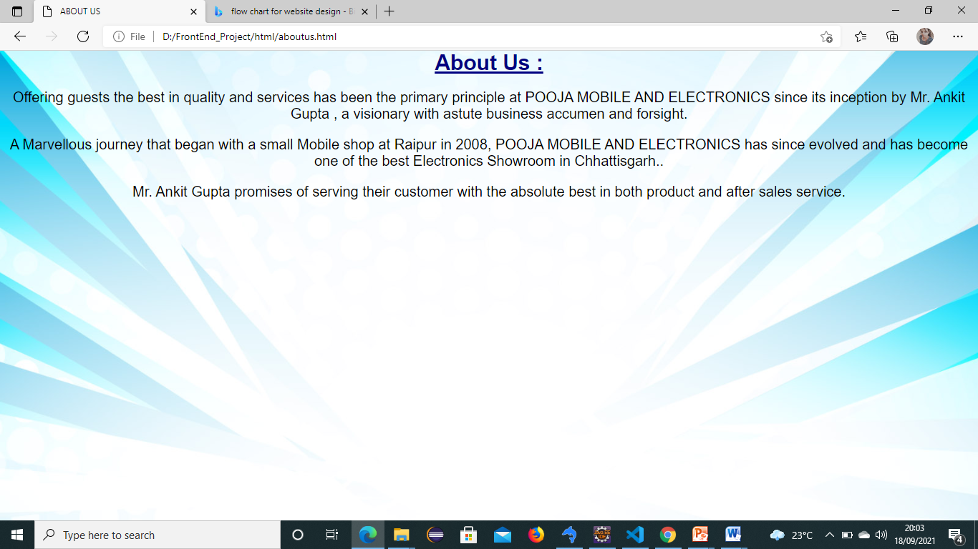

**SERVICES PAGE:**

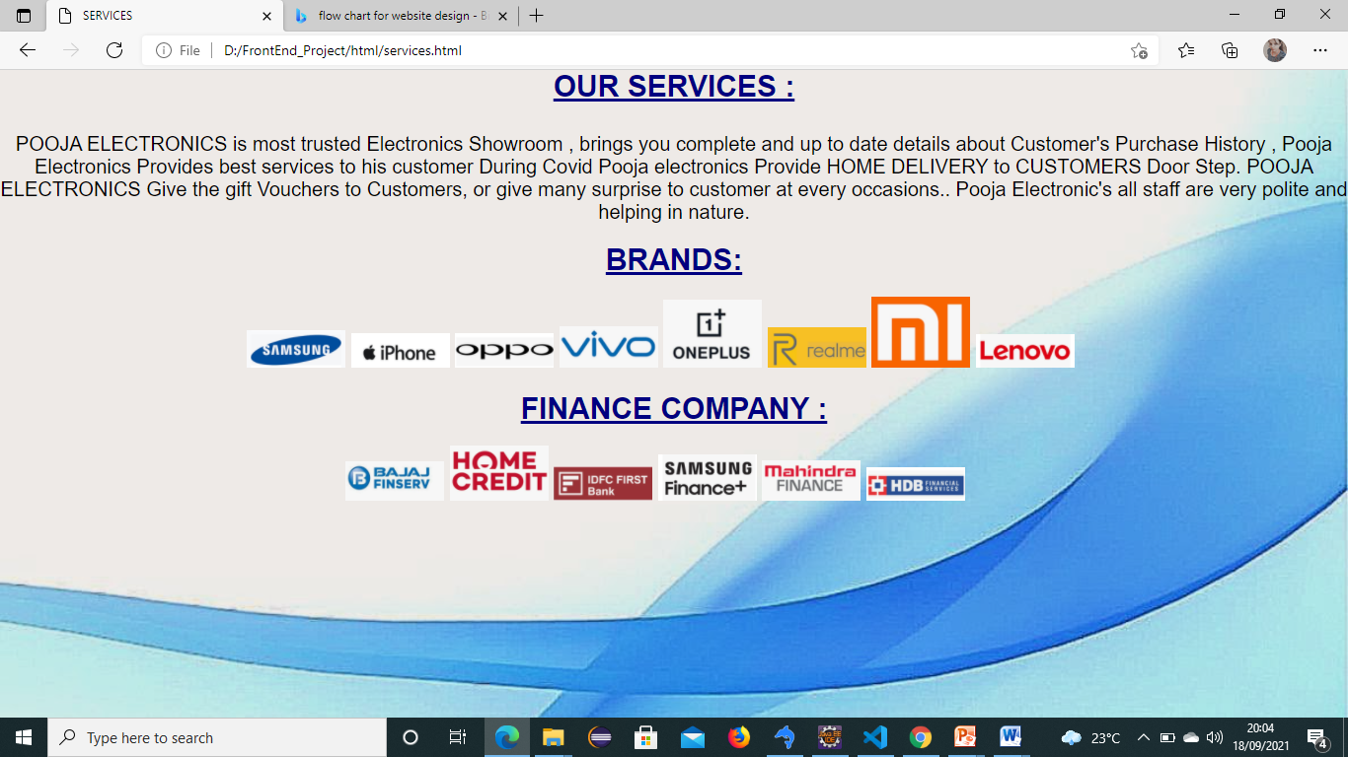

**CONTACT US PAGE:**

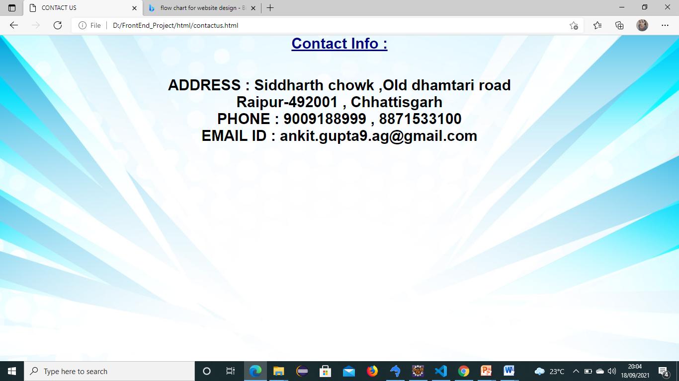

**GALLERY PAGE:**

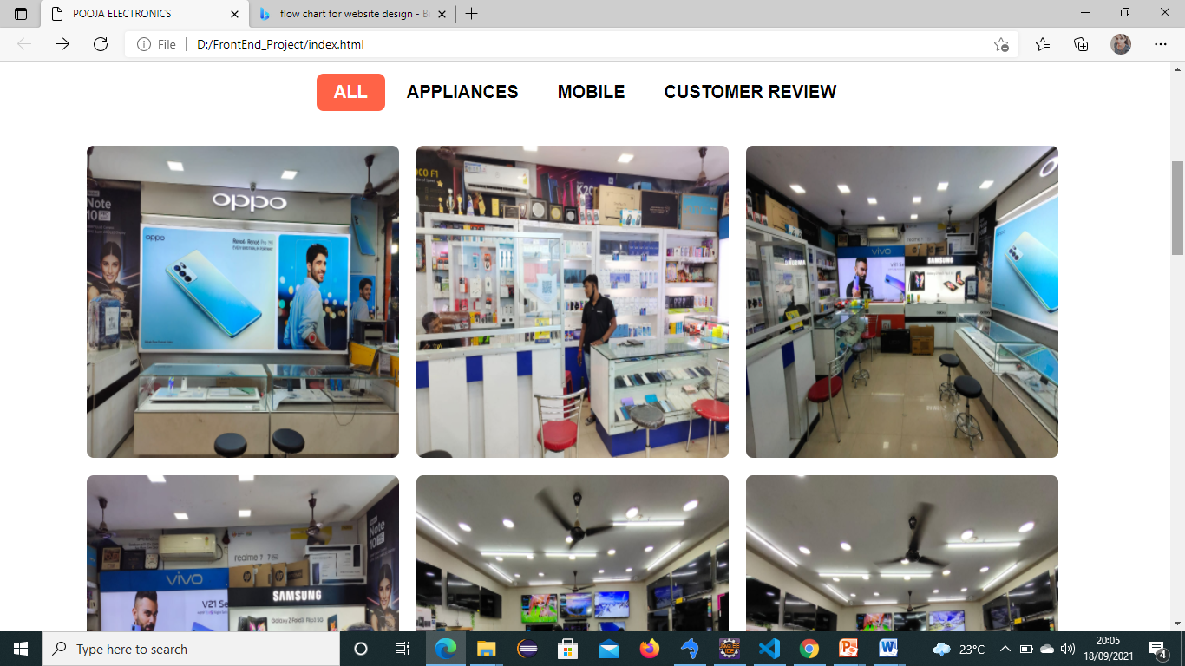

**APPLIANCES GALLERY PAGE:**

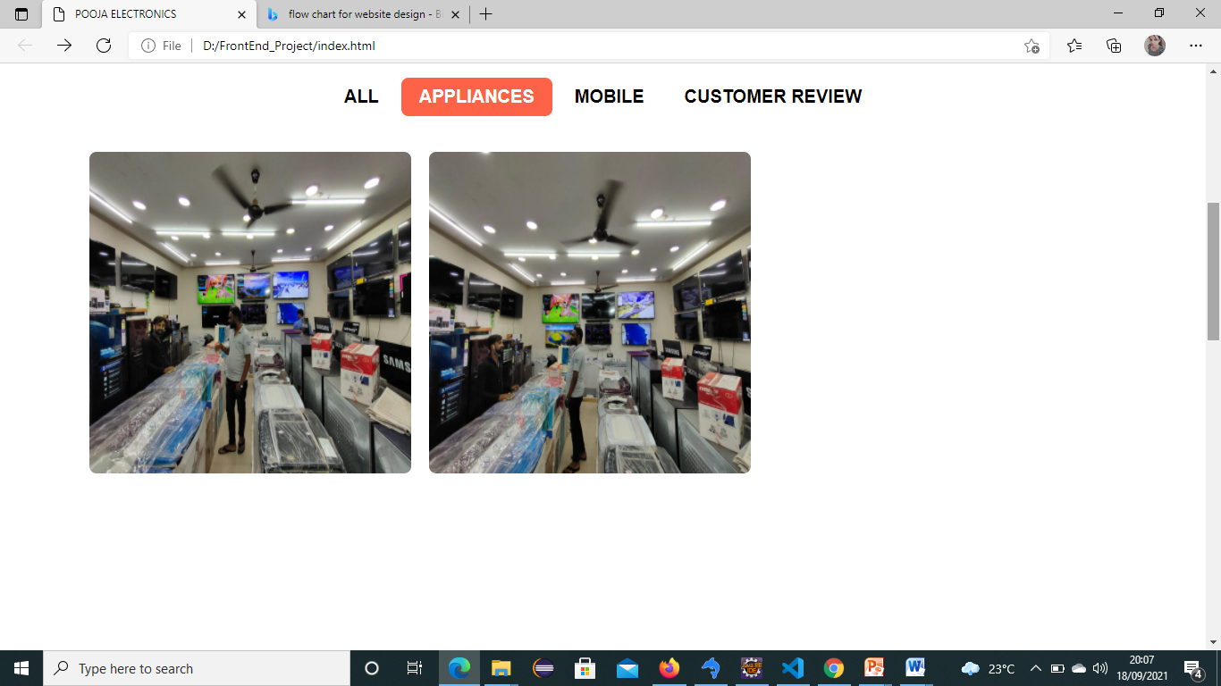

**MOBILE GALLERY PAGE:**

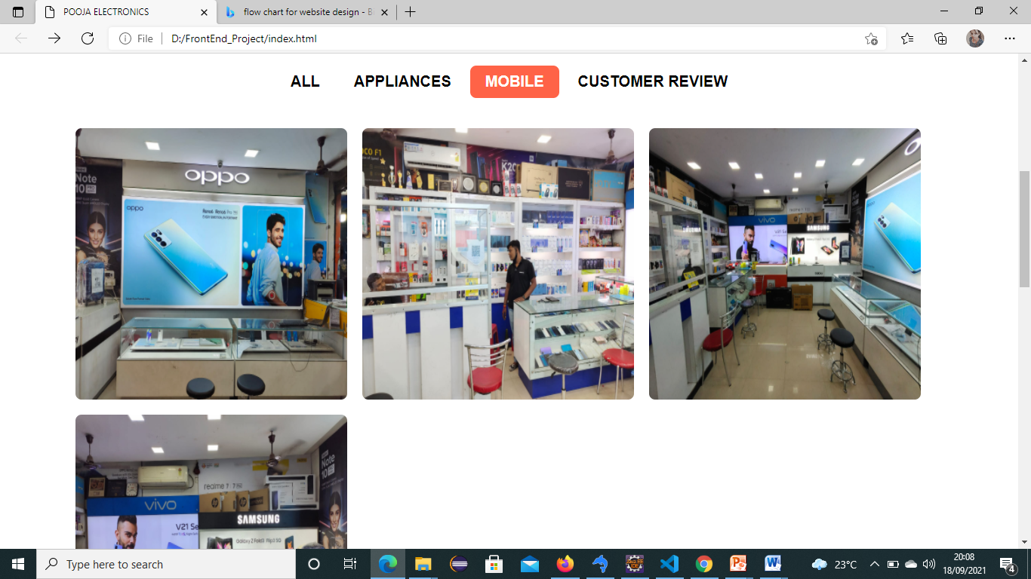

**OUR INFORMATION PAGE:**

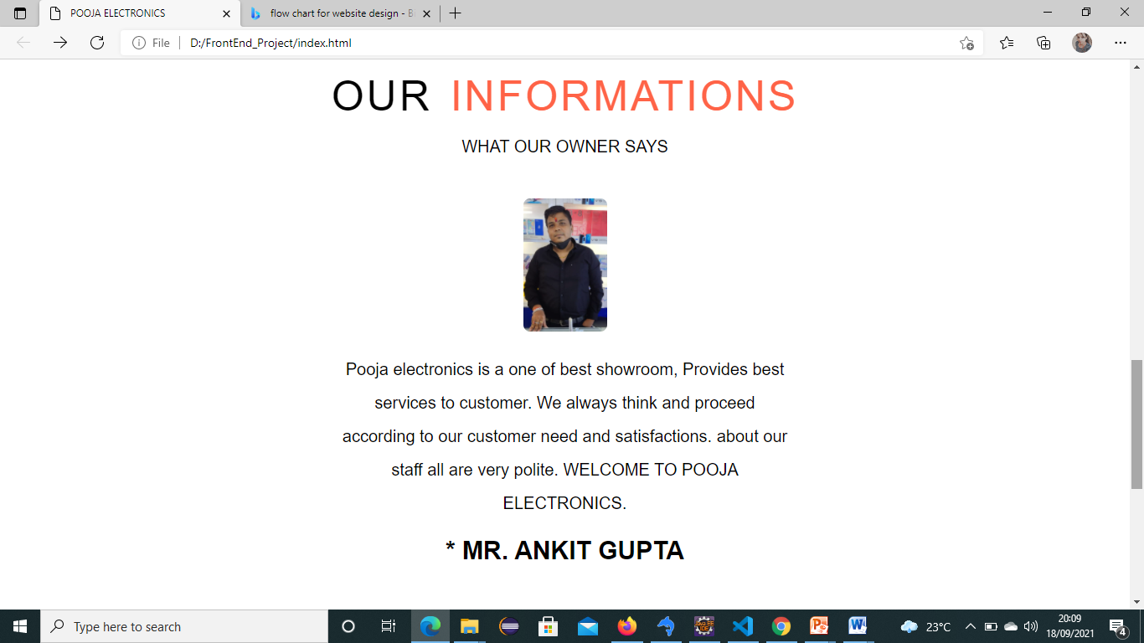

**FACEBOOK PAGE:**

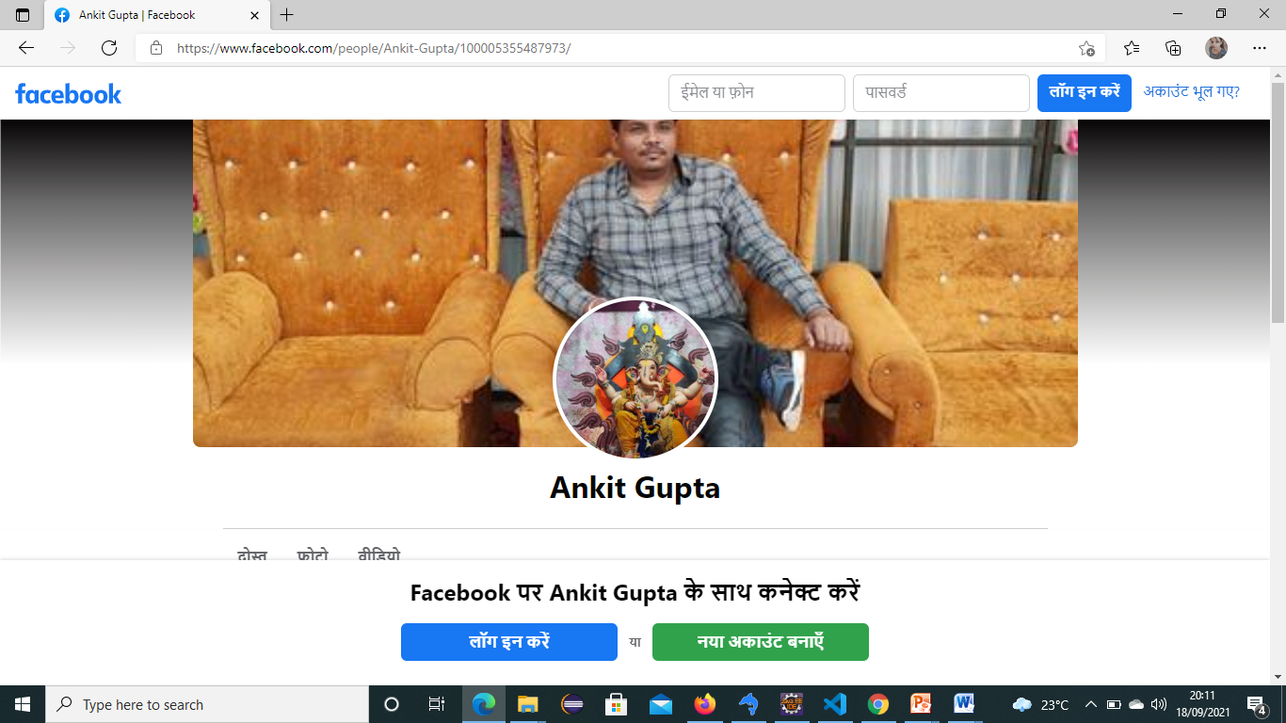

**WHATSAPP PAGE:**

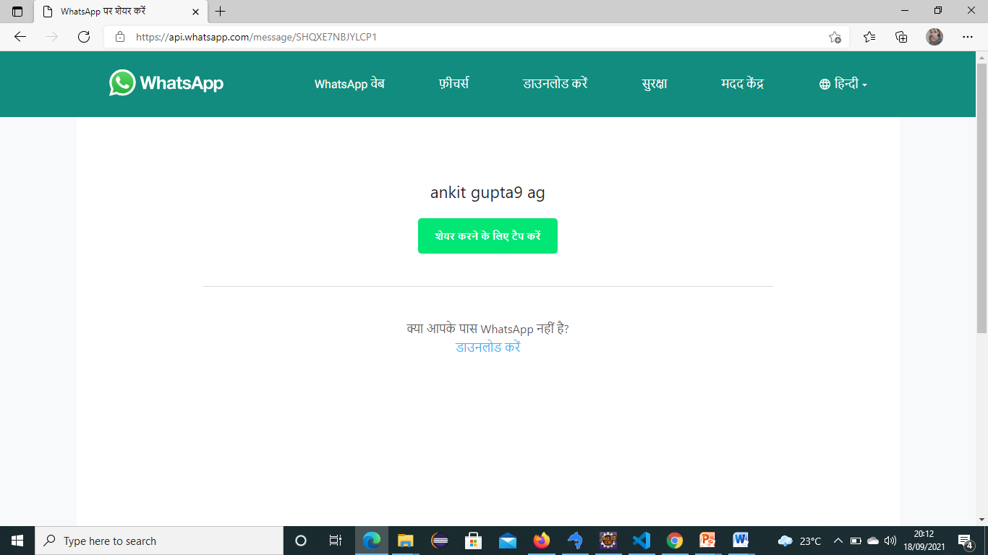

**INSTAGRAM PAGE:**

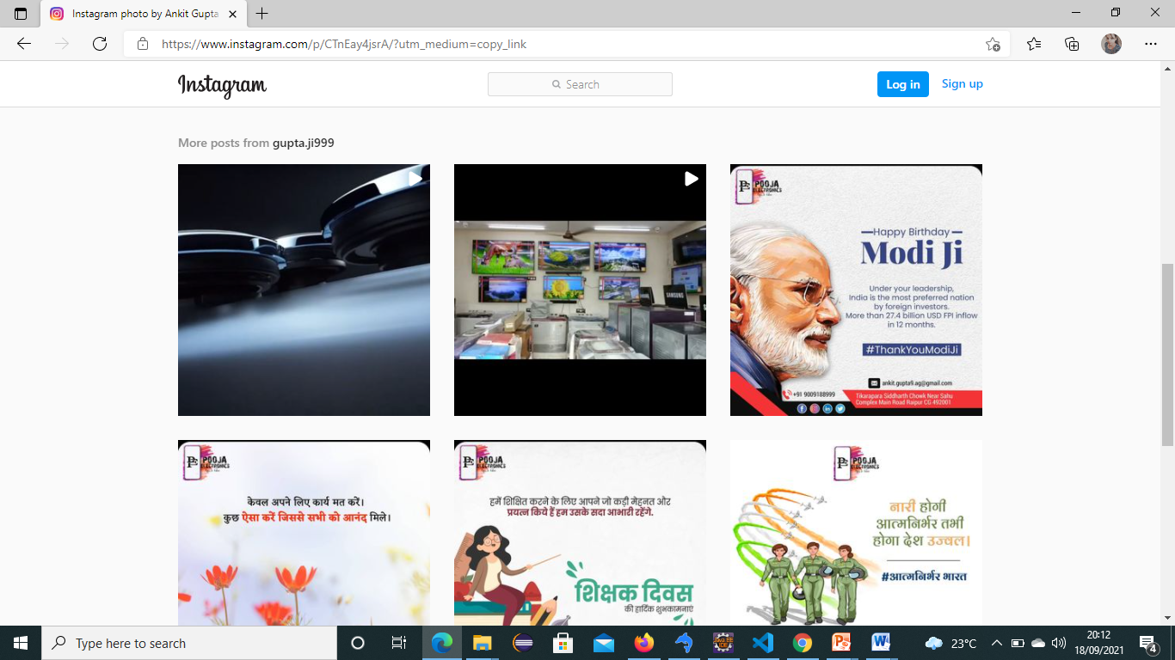

**FOOTER PAGE PAGE:**

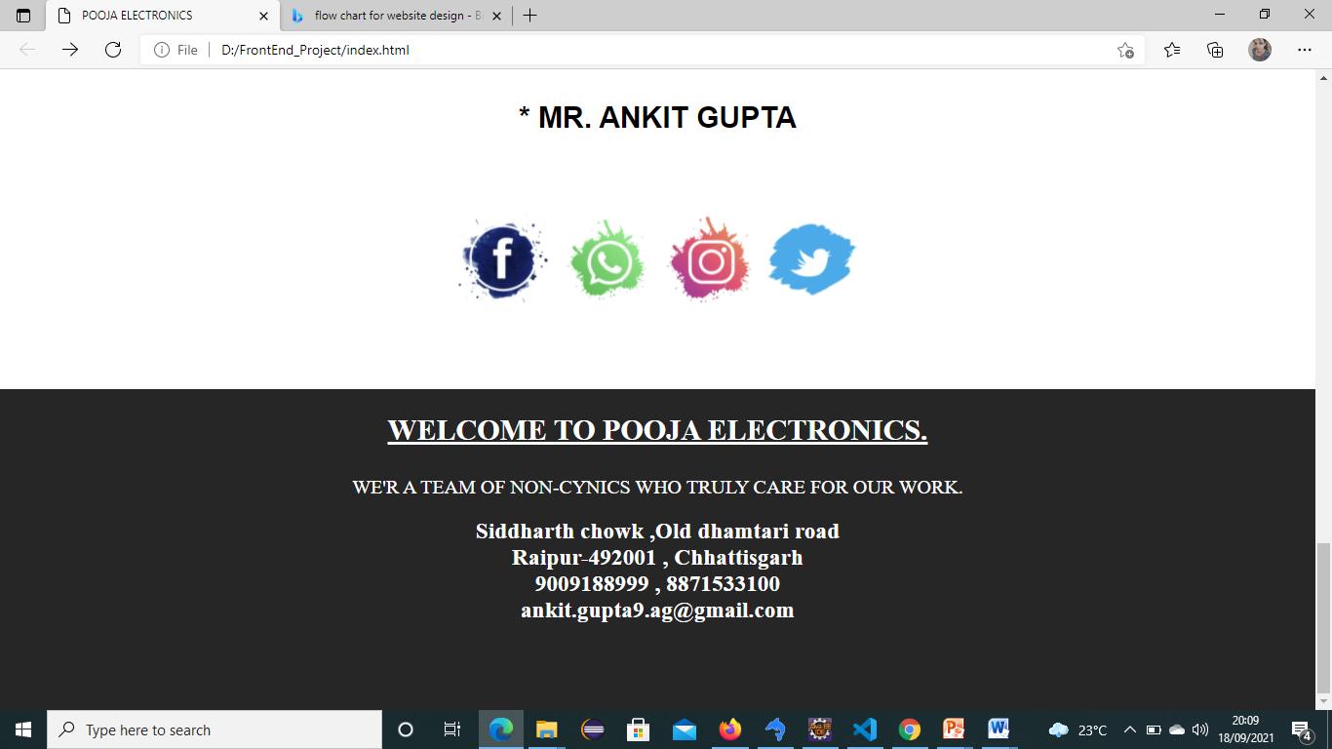

**CONCLUSION**

Websites are playing important part in improvement of business.70% of the population is using dynamic and interactive websites because of their eye capturing visual effects. Static websites also have their own place for the platform where there is specific information required. Static websites require less investment as compare to dynamic websites.

* This will allow customer to play order without even visiting the shop.
* Being able to buy any time , any place , anywhere.
* Site enables them to browse before they shop , and to research the product so they have more confidence in what they are buying.
* Online shopping become more enjoyable and easier than real-world shopping.

**REFERENCE:**

[www.edubridgeindia.com](http://www.edubridgeindia.com)